Introduction
Hello, I’m doing some concepting here and thought I’d put it in a reasonably readable format because I might share it with artists or musicians or something. This document is about “Items” which here means active items (primarily weapons) and passive items. This being a Vampire Survivors clone, many level ups will consist of acquiring or upgrading items randomly obtained from an item pool.
Oh and hey the theme portion got so long I gave it its own file

Item Sets/Themes
I would like the items to be grouped thematically, like maybe a demonic themed set and a nature themed set, etc. Items from a set should generally have more synergy with other items from their set than with any other set, but there should be enough synergy with other sets that not every game feels like "pick a set and stick with it".
- "Black sheep" items will also be expected; a few bumps in the road to complicate the meta.
- "married" sets may be interesting, or set pairs that have more synergy with their spouse set than with their own.
- I'm also toying with the idea of elemental effects and elemental weaknesses/resistances. This would be a good way to discourage over-reliance on a single set and lends itself easily to sets (electric, ice, fire, dark, etc.) I could also add a little more structure by having no sets with a single element, but every set has 2 elements, like a thunderstorm set that has water and electric.
- Megaloot/TFT style set bonuses are not out of the question. They're also a good way to discourage over-reliance on single sets
- Many if not all sets should tend toward an archetype, like crit, DOT, tank, etc.

Total Item Count
I do kind of need to come up with a total active and total passive count to reel in the scope unfortunately, which would of course also limit the number of sets. There will be a roughly- or maybe exactly- equal number of active and passive items.
- 8-40 sets
- of 5-9 items each
- Total of 40-200 items

Set Ideas
Here’s some ideas for sets, I tried to put the more complete ideas up front. Ideas include archetypes the sets would mesh well with as well as ideas for specific attacks or passives.
- Fire – there will certainly be damage over time effects in this game, and fire is one of the obvious ones.
  - A flamethrower attack
  - Fire dot – perhaps given an identity as %maxHP DOT?
- Ice – A slow and/or freeze set seems important
  - Not all weapons should be focused on freezing and slowing- then it’s just like you have 5 of the same weapon.
  - Crits? (because ice is sharp)
  - Icicle fan attack
- Poison – Maybe not necessarily its own set, but I do want a poison DOT in the game.
  - If fire’s thing is %maxHP damage, perhaps poison’s thing could be flat damage. To make it a little more interesting, maybe frontloaded flat damage, as in the dps decays over time. This would make it even better suited against low maxHP targets than it already was.
  - Or, maybe backloaded damage/ramping dps, like “badly poisoned” in pokemon. This would muddy its specialization a bit (flat damage is good against low maxHP targets, ramping damage is bad against them), but it opens an opportunity for a mirror of bleed’s effect- since it definitely doesn’t make sense to have a ramping damage bleed.
- Bleed – Another DOT I’m pretty sure I want in the game, doesn’t necessarily need its own set
  - Fire and poison will probably deal damage 1-2x per second. Bleed will be much faster, either about 5x a second, or every frame.
  - Bleed might also deal true damage, if such a mechanic even exists
  - Bleed might also have decaying dps, to simulate blood clotting
  - Should be a visible blood trail behind the enemy
- Electricity Set – when I think of an electricity set I think of crit builds and energy shield- partially because electricity is legitimately a good fit for those features, but also because of Spellbook Demonslayers. I swear I’ve played more than 1 Vampire Survivors clone but I really like Spellbook Demonslayers so I will probably struggle through much of the project to make this game distinct from that one. Some other features an electric set may have-
  - Randomly targeting attacks
  - Movement speed
  - Attack speed
  - Stun

- I really want a set themed around black and red. Or maybe a "married" pair, one black, one red. Just because it's pretty.
  - Blood is red, and blood is cool, so the red set could be themed around blood. Maybe an attack like this, which has a reason to be red
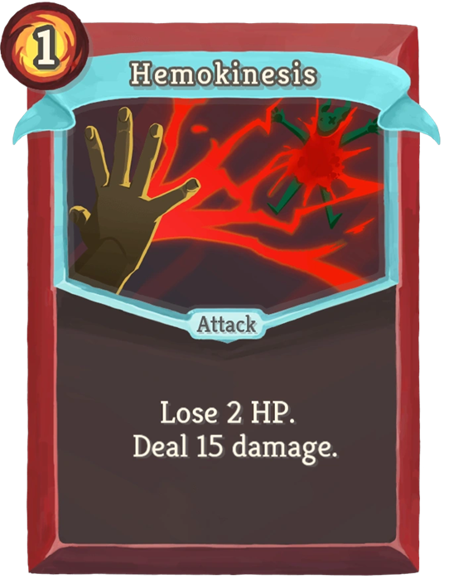
Or just attacks that happen to be red, like red chain lightning or a melee attack that shows a red arc from a sword swing.
  - As for black, maybe just dark/evil/voidy things?

Additional Set Concept
I may also expand the evolution feature of the game to be multi-stage and branching. Then perhaps each set starts with a single item, like a basic fireball for the fire set, and you gain the other items by evolving the fireball in different ways.
This is a fun concept, but it is challenging to combine it with the random item pool. It would result in the pool being much smaller (and therefore more boring) and there would be no rng at all in the path you take through the tree. And if you want a second fire item you’d have to what, get another fireball? I want to avoid situations where you have to get exactly the perfect item from the pool to progress your build; you should be able to create a workable build with whatever shit you find.
So I don’t want to discard the idea, but it definitely will need some work to make it into the game.

